Vulnerability Title: Nmapping

Affected Service/Ports
- Port 21 tcp is open with service ftp running version vsftpd 2.0.8 or later
- Port 22/tcp is open with service ssh running version OpenSSH 7.2p2 Ubuntu 4 (Ubuntu Linux; protocol 2.0)
- Port 3306/tcp is open with mysql running MySQL 5.7.12-0ubuntu1
- Port 666/tcp open pkzip-file .ZIP file
- Port 53/tcp is open with domain version dnsmasq 2.75
- Port 80/tcp is open with service http running version PHP cli server 5.5 or later
- Port 139/tcp is open with service netbios-ssn version Samba smbd 4.3.9-Ubuntu

CVE ID(s): The specific Common Vulnerabilities and Exposures identifier.
FTP- Vsftpd
CVE ID(s): No direct CVE — this is a misconfiguration, not a software bug. However, similar exposures have led to compromise (e.g., CVE-2011-2523 affected older vsftpd versions).
CVSS Score/Vector: 5.3 — Medium
CVSS:3.1/AV:N/AC:L/PR:N/UI:N/S:U/C:L/I:N/A:N
Severity Level: Medium
- The FTP service running on port 21 allows anonymous logins, which means any user can connect without a valid username or password. While directory listing is partially restricted (“550 Permission denied”), authentication bypass still occurs. This misconfiguration can expose sensitive files or directories to unauthorized users and can be used to gain system information or files for further attacks.
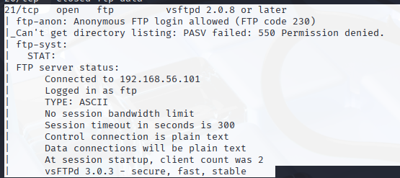

Vulnerability Title: Insecure SMB File Shares
Affected Service/Port: Samba smbd on ports 139
CVE ID(s): CVE-2017-7494 (for older Samba remote code execution issues), but primarily a configuration issue (public shares, weak policies).
CVSS Score/Vector: 7.5 — High
CVSS:3.1/AV:N/AC:L/PR:N/UI:N/S:U/C:H/I:N/A:N
Severity Level: High
Description:
The SMB file-sharing service allows unauthenticated access to several network shares (“kathy”, “tmp”). Files within these shares can be listed or downloaded without credentials. The “message signing” feature is also disabled, reducing protection against tampering or relay attacks. An attacker could exfiltrate data, discover credentials, or upload malicious files.
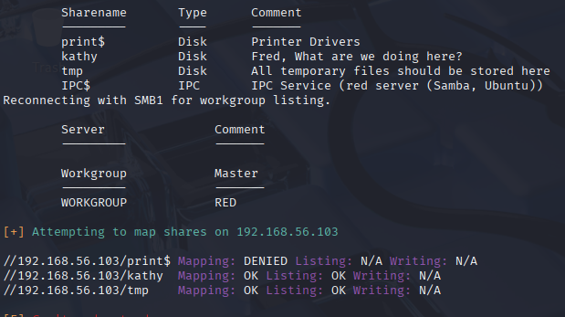
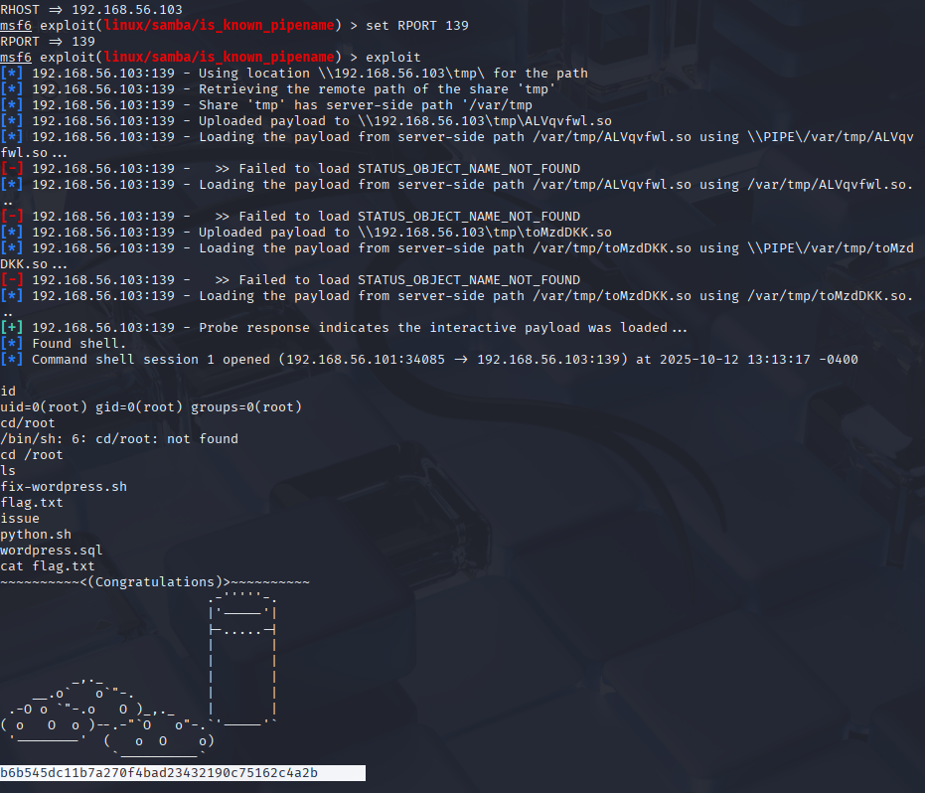
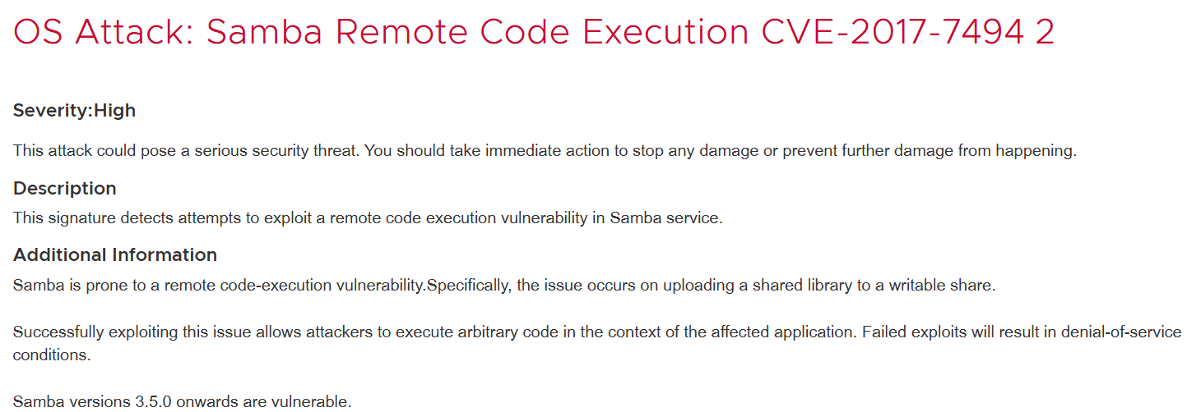

Vulnerability Title: MySQL 5.7.12 Server Version Disclosure
Affected Service/Port: MySQL on port 3306
CVE ID(s): CVE-2016-6662, CVE-2016-6663 (affect MySQL 5.7.x versions)
CVSS Score/Vector: 8.1 — High
CVSS:3.0/AV:N/AC:H/PR:L/UI:N/S:U/C:H/I:H/A:H
Severity Level: High
Description:
A MySQL service (version 5.7.12) is running and accessible on the network. Older 5.7.x versions have known vulnerabilities that allow remote attackers to gain elevated privileges or execute code by exploiting configuration injection or unsafe file writes. The version disclosure also aids attackers in identifying known exploit paths. A remote attacker can exploit this to negotiate SSLv2 ciphers and complete SSLv2 handshakes even if all SSLv2 ciphers have been disabled on the server. Note that this vulnerability only exists if the SSL_OP_NO_SSLv2 option has not been disabled.

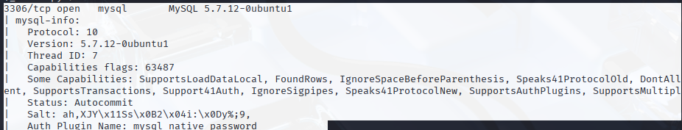

Vulnerability 4: Multiple Local Users Enumerated via SMB
Vulnerability Title: User Enumeration through SMB/RPC
Affected Service/Port: Samba RPC on ports 139,
CVE ID(s): No direct CVE — reconnaissance / information disclosure weakness
CVSS Score/Vector: 5.0 — Medium
CVSS:3.1/AV:N/AC:L/PR:N/UI:N/S:U/C:L/I:N/A:N
Severity Level: Medium
Description:
Enumeration of local user accounts was possible via the SMB/RPC interface. This can be leveraged for targeted password attacks (brute-force or credential reuse). The password policy was found to have a minimum length of 5 and no complexity requirements, increasing risk of compromise.

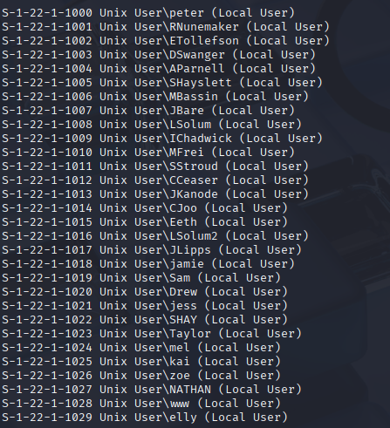

Vulnerability Title: OpenSSH 7.2p2 Version Disclosure
Affected Service/Port: SSH on port 22
CVE ID(s): CVE-2016-0777, CVE-2016-0778
CVSS Score/Vector: 7.5 — High
CVSS:3.1/AV:N/AC:L/PR:N/UI:N/S:U/C:H/I:N/A:N
Severity Level: High
Description:
The SSH service reveals that it is running OpenSSH 7.2p2, an outdated version affected by multiple vulnerabilities including information leaks via roaming (CVE-2016-0777). Although authentication is required for exploitation, version disclosure provides attackers with insight into the system’s patch level and potential exploit paths.

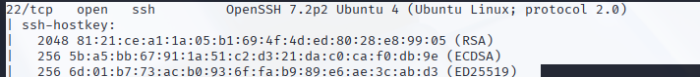

Vulnerability Title: dnsmasq 2.75 Outdated
Affected Service/Port: DNS on port 53
CVE ID(s): CVE-2017-14491 (Remote Code Execution), CVE-2017-14493 (Information Leak)
CVSS Score/Vector: 8.8 — High
CVSS:3.1/AV:N/AC:L/PR:N/UI:N/S:U/C:H/I:H/A:H
Severity Level: High
Description:
The host is running dnsmasq 2.75, which contains multiple serious vulnerabilities allowing remote code execution and information leaks. If the service is exposed to external networks, attackers could craft malicious DNS queries to execute code or read sensitive memory.
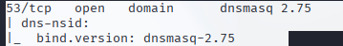

Vulnerability Title: Unidentified Service (ZIP File Header Detected)
Affected Service/Port: Unknown Service on port 666
CVE ID(s): None — requires manual verification
CVSS Score/Vector: 4.0 — Medium
CVSS:3.1/AV:N/AC:H/PR:N/UI:N/S:U/C:L/I:N/A:N
Severity Level: Medium
Description:
A non-standard service is running on port 666 and appears to send data resembling a ZIP archive header (PKZIP). This may indicate an exposed internal file or an improperly configured custom service. Such exposures can lead to data leaks or serve as an entry point for further exploitation. Possible data leak occurring.
